**User Manual for MTGCatalog**

**Product:** MTGCatalog v1.1

**Who is this for?:** This product is intended for use by collectors of the trading card game Magic the Gathering (referred to as MTG from here on). However, despite the name MTGCatalog, this application may also suffice for collectors of other trading card products.

**Features:** MTGCatalog has four main features at user’s disposal. The first is the “Add” feature. This allows the user to input a card name, quality, and price into the input boxes and submit them into the user’s own catalog.

The second is the “Collection” feature. This allows the user to view the list of cards in their collection that they have already input. It lists the card name, quality, and value. Also, the information from the collection is used to display the overall value of the user’s collection on the main window.

The third function is the “Delete” function. This allows user’s to remove a card from the user’s catalog. This will remove the card from the catalog. Due to the possibility of having multiple copies of a card, the ID # of the card is used instead.

The last function is the “Refresh” function. This is used to refresh the total of the card collection in the main window after adding a card to the catalog or deleting a card.

1. **Card Name:**  User inputs the card name here.
2. **Card Quality:** User inputs the quality of the card here. Note the possible inputs listed below the input box (NM, LP, MP, HP, DMG).
3. **Card Price:** User inputs the price of the card here.
4. **Add to Card Catalog:** This button accepts the user’s input to add the card to the catalog. If invalid input is given, the card will not add to the collection
5. **Enter Card ID #:** This is where the user types the ID of the card they wish to delete.
6. **Delete Card from Collection:** This button will delete the card with the matching ID from the catalog. Note that an error will appear if the input ID does not match a card in the database.
7. **Show Card Collection:** Opens the catalog of cards the user has input.
8. **Total Value:** This is where the user’s total collection value is displayed
9. **Refresh Total:** This button refreshes the Total Value to accurately show the collection value.
10. **Exit MTGCatalog:** This button will close the application for the user.

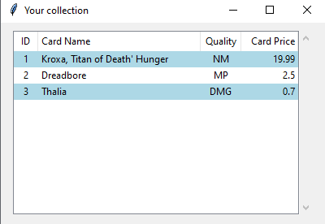

This is the window for “Your Collection.” This displays the user’s cards that have been input so far. When the user is done viewing the window, it is closed using the X in the top-right corner.

**User Tips/Warnings**

**-** The application’s windows do not automatically update. If the collection window is open when a user adds or deletes a card, they need to close and open the window to see the changes.

- The input for Card Quality must be NM, LP, MP, HP, or DMG. Any other input will end in an error.

- The user will also be given an error message if they input anything other than numbers and decimals into the Card Price input.

**Installation**

The user installs this product by downloading the zip file containing HoggMaxwellFinalProject.py and unzipping it. The first time the application is ran, a database file named “card_catalog.db” will be created. This is where user’s data involving MTGCatalog is stored.